**ASSIGNMENT-1**

**Dept Table:**

|  |  |  |
| --- | --- | --- |
| **DeptNo** | **Dname** | **Loc** |
| 10 | Accounts | Bangalore |
| 20 | IT | Delhi |
| 30 | Production | Chennai |
| 40 | Sales | Hyd |
| 50 | Admn | London |

**Emp Table:**

|  |  |  |  |  |  |  |
| --- | --- | --- | --- | --- | --- | --- |
| **EmpNo** | **Ename** | **Sal** | **Hire_Date** | **Commission** | **DeptNo** | **Mgr** |
| 1001 | Sachin | 19000 | 1-Jan-1980 | 2100 | 20 | 1003 |
| 1002 | Kapil | 15000 | 1-Jan-1970 | 2300 | 10 | 1003 |
| 1003 | Stefen | 12000 | 1-Jan-1990 | 500 | 20 | 1007 |
| 1004 | Williams | 9000 | 1-Jan-2001 | NULL | 30 | 1007 |
| 1005 | John | 5000 | 1-Jan-2005 | NULL | 30 | 1006 |
| 1006 | Dravid | 19000 | 1-Jan-1985 | 2400 | 10 | 1007 |
| 1007 | Martin | 21000 | 1-Jan-2000 | 1040 | NULL | NULL |

1. Select employee details of dept number 10 or 30
2. Write a query to fetch all the dept details with more than 1 Employee.
3. Write a query to fetch employee details whose name starts with the letter “**S”**
4. Select Emp Details Whose experience is more than 2 years
5. Write a SELECT statement to replace the char “a” with “#” in Employee Name ( Ex: **Sachin** as **S#chin)**

1. Write a query to fetch employee name and his/her manager name.
2. Fetch Dept Name , Total Salry of the Dept
3. Write a query to fetch **ALL** the employee details along with department name, department location, irrespective of employee existance in the department.
4. Write an update statement to increase the employee salary by 10 %
5. Write a statement to delete employees belong to Chennai location.
6. Get Employee Name and gross salary (sal + comission) .
7. Increase the data length of the column Ename of Emp table from 100 to 250 using ALTER statement
8. Write query to get current datetime
9. Write a statement to create STUDENT table, with related 5 columns
10. Write a query to fetch number of employees in who is getting salary more than 10000
11. Write a query to fetch minimum salary, maximum salary and average salary from emp table.
12. Write a query to fetch number of employees in each location
13. Write a query to display emplyee names in descending order

1. Write a statement to create a new table(**EMP_BKP**) from the existing **EMP** table
2. Write a query to fetch first 3 characters from employee name appended with salary.

21) Get the details of the employees whose name starts with **S**

22) Get the details of the employees who works in Bangalore location

23) Write the query to get the employee details whose name started within any letter between A and K

2 4) Write a query in SQL to display the employees whose manager name is **Stefen**

25) Write a query in SQL to list the name of the managers who is having maximum number of employees working under him

**SOLUTIONS**

CREATE TABLE Department(

Depart_num INT PRIMARY KEY,

Dname VARCHAR(20),

Loc VARCHAR(20)

);

CREATE TABLE Employee(

empNo INT PRIMARY KEY,

Ename VARCHAR(40),

salary INT,

hire_date DATE,

commision INT,

Depart_num INT,

FOREIGN KEY(Depart_num) REFERENCES Department(Depart_num) ON DELETE SET NULL,

mgr INT

);

INSERT INTO Department VALUES(10,'Accounts','Bangalore');

INSERT INTO Department VALUES(20,'IT','Delhi');

INSERT INTO Department VALUES(30,'Production','Chennai');

INSERT INTO Department VALUES(40,'Sales','Hyd');

INSERT INTO Department VALUES(50,'Admn','London');

SELECT * FROM Department;

INSERT INTO Employee VALUES(1001,'sachin',19000,'1980-01-01',2100,20,1003);

INSERT INTO Employee VALUES(1002,'kapil',15000,'1970-01-01',2300,10,1003);

INSERT INTO Employee VALUES(1003,'stefen',12000,'1990-01-01',500,20,1007);

INSERT INTO Employee VALUES(1004,'williams',9000,'2001-01-01',NULL,30,1007);

INSERT INTO Employee VALUES(1005,'jhon',5000,'2005-01-01',NULL,30,1006);

INSERT INTO Employee VALUES(1006,'dravid',19000,'1985-01-01',2400,10,1007);

INSERT INTO Employee VALUES(1007,'martin',21000,'2000-01-01',1040,NULL,NULL);

INSERT INTO Employee VALUES(1008,'shakir',2000,'2028-01-01',1030,NULL,NULL);

SELECT * FROM Employee;

-- 1) Select employee details of dept number 10 or 30

SELECT * FROM Employee

WHERE (Depart_num = 10) OR (Depart_num = 30);

**Screenshot:**

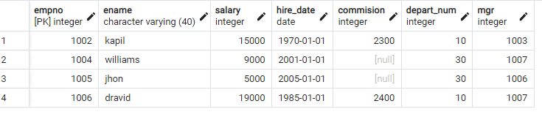

-- 2) Write a query to fetch all the dept details with more than 1 Employee.

SELECT Employee.empNo,Employee.Ename,Department.*

FROM Employee INNER JOIN Department

on Employee.Depart_num = Department.Depart_num;

**Screenshot:**

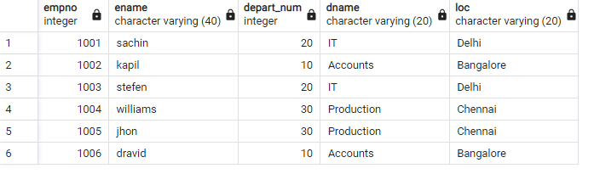

-- 3) Write a query to fetch employee details whose name starts with the letter “S”

SELECT *

FROM Employee

WHERE Ename LIKE 's%';

**Screenshot:**

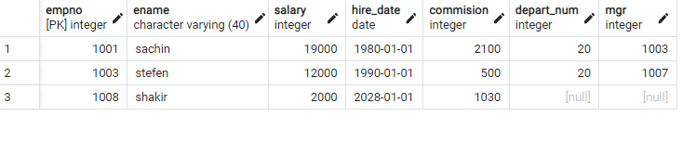

-- 4) Select Emp Details Whose experience is more than 2 years

SELECT * FROM Employee WHERE EXTRACT (YEAR FROM age(CURRENT_DATE,Hire_date))>2 ORDER BY Employee;

**Screenshot:**

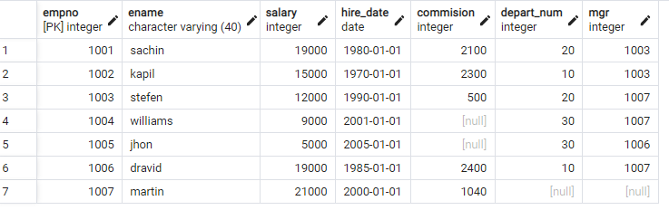

-- 5) Write a SELECT statement to replace the char “a” with “#” in Employee Name ( Ex: Sachin as S#chin)

SELECT REPLACE(Ename,'a','#') FROM Employee3;

SELECT Ename FROM Employee;

**Screenshot:**

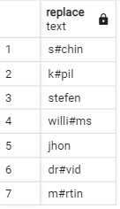

-- 6) Write a query to fetch employee name and his/her manager name.

SELECT E.Ename AS EMPLOYEE,

MA.Ename AS MANAGER

FROM Employee2 MA

INNER JOIN Employee2 E

ON E.mgr = MA.empNo;

**Screenshot:**

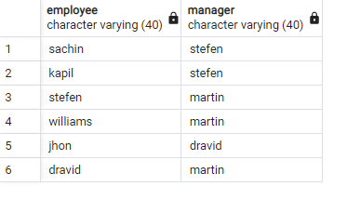

-- 7) Fetch Dept Name , Total Salry of the Dept

SELECT Employee.Ename,Department.Dname,SUM(Employee.salary) AS salary

FROM Employee

INNER JOIN Department ON Employee.Depart_num = Department.Depart_num

GROUP BY Employee.Ename,Department.Dname

**Screenshot:**

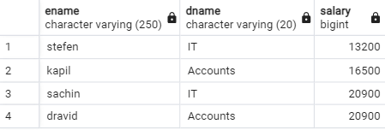

-- 8) Write a query to fetch ALL the employee details along with department name, department location, irrespective of employee existance in the department.

SELECT e.empNo,

e.Ename,

e.salary,

e.mgr,

e.hire_date,

e.salary,

e.commision,

e.Depart_num,

d.Dname,

d.Loc

FROM Employee e,

Department d

WHERE e.Depart_num = d.Depart_num;

**Screenshot:**

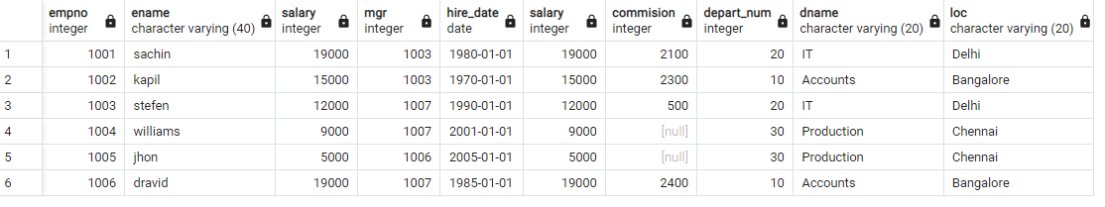

-- 9) Write an update statement to increase the employee salary by 10 %

UPDATE Employee SET salary= salary + (salary * 10 / 100);

UPDATE Employee SET salary= salary + (salary * 10 / 100);

**Screenshot:**

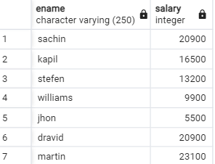

-- 10) Write a statement to delete employees belong to Chennai location.

DELETE FROM Employee WHERE empNo IN(

SELECT empNo

FROM Employee

INNER JOIN Department ON Employee.Depart_num = Department.Depart_num

WHERE Department.Loc = 'Chennai'

);

**Screenshot:**

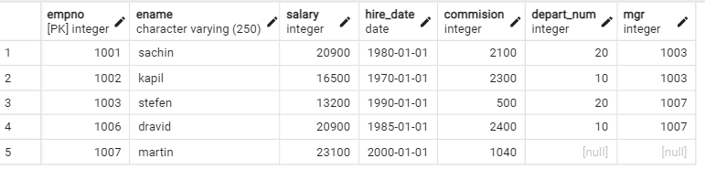

-- 11) Get Employee Name and gross salary (sal + comission)

SELECT

ENAME, SALARY, COMMISION,

(SALARY + COMMISION) AS "TOTAL_SALARY"

FROM EMPLOYEE;

**Screenshot:**

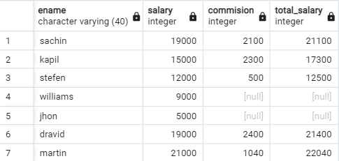

--12) Increase the data length of the column Ename of Emp table from 100 to 250 using ALTER statement

ALTER TABLE Employee

ALTER COLUMN Ename TYPE VARCHAR(250);

**Screenshot:**

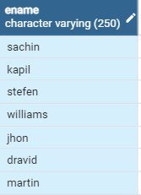

-- 13) Write query to get current datetime

SELECT NOW();

**Screenshot:**

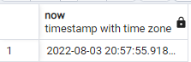

-- 14) Write a statement to create STUDENT table, with related 5 columns

CREATE TABLE Student(

student_usn VARCHAR(30) PRIMARY KEY,

stud_name VARCHAR(30),

student_age INT,

student_address VARCHAR(45),

student_branch VARCHAR(30)

);

**Screenshot:**

SELECT * FROM Student;

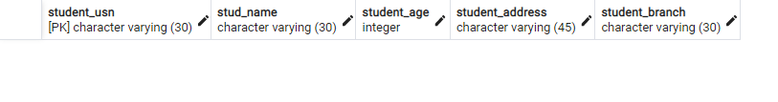

-- 15) Write a query to fetch number of employees in who is getting salary more than 10000

SELECT COUNT(*) FROM Employee

WHERE salary > 10000;

**Screenshot:**

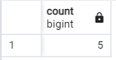

-- 16) Write a query to fetch minimum salary, maximum salary and average salary from emp table.

SELECT MIN(salary),MAX(salary),AVG(salary) FROM Employee;

**Screenshot:**

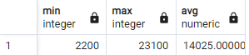

-- 17) Write a query to fetch number of employees in each location

SELECT COUNT(*) AS COUNT,Department.Loc

FROM Employee

INNER JOIN Department ON Employee.Depart_num = Department.Depart_num

GROUP BY Department.Loc

SELECT * FROM Department;

SELECT * FROM Employee;

**Screenshot:**

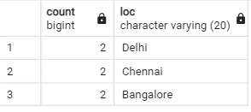

-- 18) Write a query to display emplyee names in descending order

SELECT Ename FROM Employee2 ORDER BY Ename DESC;

**Screenshot:**

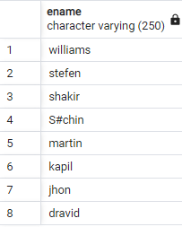

-- 19) Write a statement to create a new table(EMP_BKP) from the existing EMP table

CREATE TABLE EMP_BKP AS

SELECT empNo,Ename,salary,hire_date,commision,Depart_num,mgr

FROM Employee;

SELECT * FROM EMP_BKP;

**Screenshot:**

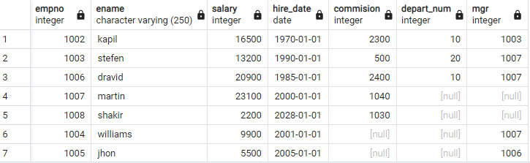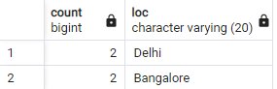

-- 20) Write a query to fetch first 3 characters from employee name appended with salary.

SELECT CONCAT(SUBSTRING(Ename,1,3),salary) AS Namesalary From Employee2

**Screenshot:**

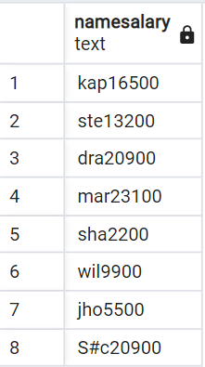

-- 21) Get the details of the employees whose name starts with S

SELECT *

FROM Employee

WHERE Ename LIKE 's%';

**Screenshot:**

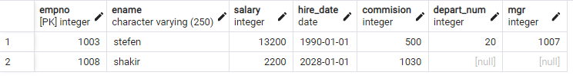

-- 22) Get the details of the employees who works in Bangalore location

SELECT Employee.empNo,Employee.*, Department.Loc

FROM Employee

INNER JOIN Department ON Employee.Depart_num = Department.Depart_num

WHERE Department.Loc = 'Bangalore';



-- 23) Write the query to get the employee details whose name started within any letter between A and K

SELECT Ename FROM Employee WHERE Ename BETWEEN 'a' and 'k';

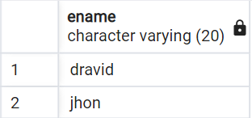

-- 24) Write a query in SQL to display the employees whose manager name is Stefen

SELECT *

FROM Employee

WHERE mgr IN

(SELECT empNo

FROM Employee

WHERE Ename = 'stefen');

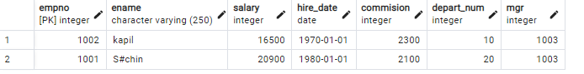

-- 25) Write a query in SQL to list the name of the managers who is having maximum number of employees working under him

SELECT m.Ename,

count(*)

FROM Employee2 w,

Employee2 m

WHERE w.mgr = m.empNo

GROUP BY m.Ename

HAVING count(*) =

(SELECT MAX (mycount)

FROM

(SELECT COUNT(*) mycount

FROM Employee2

GROUP BY mgr) a);

